# Mandatory exercise 1

## Make a list of data you think that Telenor needs to store.

Details required for Telenor database:

* Unique user id
* Name
* Date of birth
* Address
* ID number
* Contact number
* Phone number
* Contract number
* Voice call allowance
* Voice call minutes used
* Text message allowance
* Text message used
* Data allowance
* Data used
* Cost
* Bank account

## Show how these data can be stored in tables (draw 3-5 tables and fill in 3 rows of example data for each table).

This data can be split into three tables; client personal details, client contract details, client usage details.

|  |  |  |  |  |  |
| --- | --- | --- | --- | --- | --- |
| **Personal details** |  |  |  |  |  |
| Unique user id | Name | Date of birth | Address | ID number | Contact number |
| 15146 | Quintillus McQueen | 10/01/1970 | 1 Karl Johans Gate, Oslo | 10017012345 | 90090901 |
| 15147 | Bogdan Jakolin | 20/02/1970 | 2 Karl Johans Gate, Oslo | 20027012345 | 90164826 |
| 15148 | Mark Polzin | 30/03/1970 | 3 Karl Johans Gate, Oslo | 30037012345 | 90090903 |

|  |  |  |  |  |  |  |  |
| --- | --- | --- | --- | --- | --- | --- | --- |
| **Contract details** |  |  |  |  |  |  |  |
| Unique user id | Phone number | Voice call allowance | Text message allowance | Data allowance | Cost | Bank account | Address |
| 15146 | 90090901 | 1000 | 1000 | 1000 | 149 | 10210.120.125 | 1 Karl Johans Gate, Oslo |
| 15147 | 90090902 | 2500 | 5000 | 5000 | 349 | 25621.345.946 | 2 Karl Johans Gate, Oslo |
| 15148 | 90090903 | 1000 | 1000 | 1000 | 149 | 15746.265.945 | 3 Karl Johans Gate, Oslo |

|  |  |  |  |  |  |  |  |
| --- | --- | --- | --- | --- | --- | --- | --- |
| **Usage details** |  |  |  |  |  |  |  |
| Unique user id | Phone number | Voice call allowance | Voice call used | Text message allowance | Text message used | Data allowance | Data used |
| 15146 | 90090901 | 1000 | 156 | 1000 | 45 | 1000 | 941 |
| 15147 | 90090902 | 2500 | 890 | 5000 | 1697 | 5000 | 4621 |
| 15148 | 90090903 | 1000 | 965 | 1000 | 689 | 1000 | 24 |

## 1.3 & 1.4 Check if any of the tables depend on each other (explain) and underline possible unique identificators in each table. Draw a simple map of the relations as shown in the figure, if any relation between the tables. Draw a line between the tables and columns that are related.

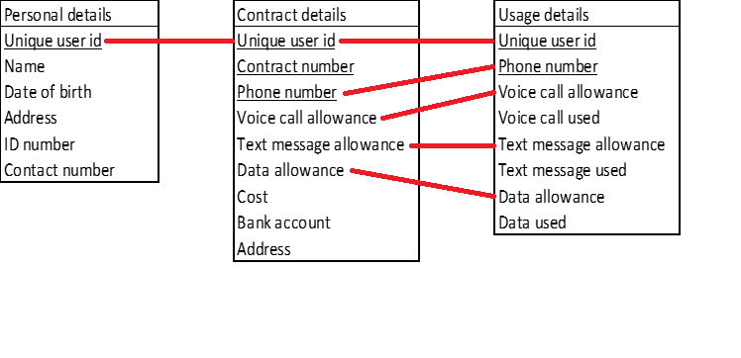

The ‘unique user id’ can be used as a GUID to link a client to a contract and to a table tracking real time usage. The ‘contract number’ can also be used as a GUID. The ‘phone number’ associated with this contract can also be used within the Telenor database as a GUID.

Tracking the client usage needs the limits stipulated by the type of contract, therefore these details will be shared between the two tables.

## 2.1 Make the database "University" and write the command you used.

Created University database:

CREATE DATABASE University;

## 2.2 Import university.sql to the university database. Write a short description of the way it was done and the commands used. Show the output from the command SHOW TABLES; in the university database.

Opened University database:

USE University;

Sourced provided sql file:

SOURCE university.sql;

SHOW TABLES output:

+------------------------------+

| Tables_in_University |

+------------------------------+

| Course |

| Department |

| Enrollment |

| Instructor |

| Location |

| Prerequisite |

| Qualified |

| Section |

| Student |

+------------------------------+

9 rows in set (0,00 sec)

## 2.3 What is a primary key and which primary keys exist in the tables of this database?

Identified primary keys of University database:

DESCRIBE Course;

primary key: crs_code

DESCRIBE Department;

primary key: dep_code

DESCRIBE Enrollment;

primary key: stu_id

primary key: sec_id

DESCRIBE Instructor;

primary key: ins_id

DESCRIBE Location;

primary key: loc_code

DESCRIBE Prerequisite;

primary key: crs_code

primary key: crs_requires

DESCRIBE Qualified;

primary key: ins_id

primary key: crs_code

DESCRIBE Section;

primary key: sec_id

DESCRIBE Student;

primary key: stu_id

## 2.4 What is a foreign key and which foreign keys are found in the tables in this database?

Identified foreign keys of University database:

DESCRIBE Course;

foreign key: dep_code

DESCRIBE Department;

None

DESCRIBE Enrollment;

None

DESCRIBE Instructor;

foreign key: dep_code

DESCRIBE Location;

None

DESCRIBE Prerequisite;

None

DESCRIBE Qualified;

None

DESCRIBE Section;

foreign key: crs_code

foreign key: loc_code

foreign key: ins_id

DESCRIBE Student;

None

## 2.5 Register data in some tables. (Write the SQL commands you are using).

### a. Register yourself as a student in the student table.

INSERT INTO Student (stu_id, stu_fname, stu_lname) VALUES (101809, ‘Tyrone’, ‘Nowell’);

### b. Register your home commune in the location table.

INSERT INTO Location (loc_code, loc_name, loc_country) VALUES (1430, ‘Aas’, ‘NO’);

### c. Register IMT in the department table.

INSERT INTO Department (dep_code, dep_name) VALUES (‘IMT’, ‘Faculty of Science and Technology’);

### d. Register INF230 in the course table.

INSERT INTO Course (crs_code, crs_title, crs_credits, dep_code, crs_description) VALUES (‘INF230’, ‘Data processing and analysis’, 10, ‘IMT’, ‘This course covers Introduction to data bases, Raw data and data processing, Analysis and methods, Query and analysis of data, Datalogging from external devices, Data and security.’);

### e. Register Ingunn Burud as instructor in the instructor table.

INSERT INTO Instructor (ins_id, ins_fname, ins_lname, dep_code) VALUES (123123, ‘Ingunn’, ‘Burud’, ‘IMT’);

## 2.6 What is possible to do? Write what you have tried and what happens. Write up some conclusions on this.

### a. Is it possible to register yourself in the enrolment table now? Why/why not?

No, an error occurs due to a duplicate entry of a primary key (student ID).

### b. Is it possible to register Ingunn as qualified instructor in INF230 in the instructor table now? Why/why not?

No, an error occurs due to a duplicate entry of a primary key (instructor ID).

### c. What do you do with students and instructors that have a middle name?

Middle names can be appended to the fname (first name) field.

### d. Can you register a course in the course table that does not have a course description? Why/why not?

No, the crs_description field doesn’t not have a default value so it will not accept the command with an undefined value. This can be avoided by setting an empty string, ‘’, to the crs_description field.

### e. What are the limitations on the loc_country in the location table?

This field is limited to two characters (char(2)) and so, it only accepts the ‘country code’.